**Katalon Studio**

Katalon studio is web and mobile automation as well as api testing. It has recording mode and scripting mode.

**Create project :**

File->New->project->select what type of testing doing example->click Api/web service

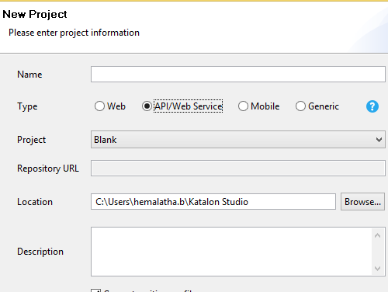

**Create Object repository:**

It place to store all web service endpoint all with information of request method url,header,conet,and authentication

Object Repository->new->webservice request

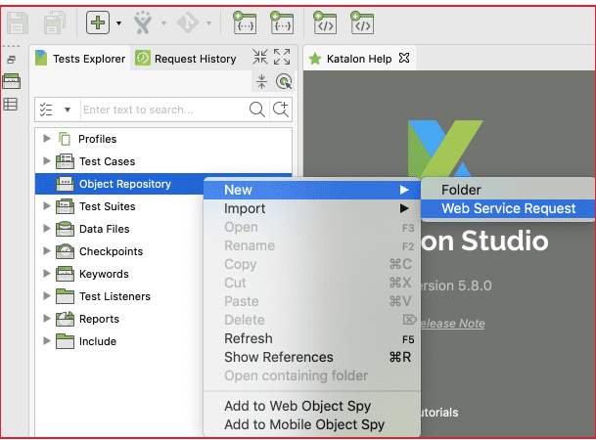

Rest type is required field.URL is not required. You can set the value into next step

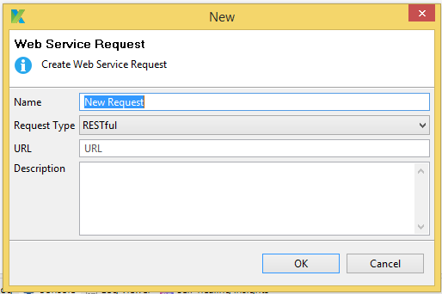

Click on ok .ready to input more details

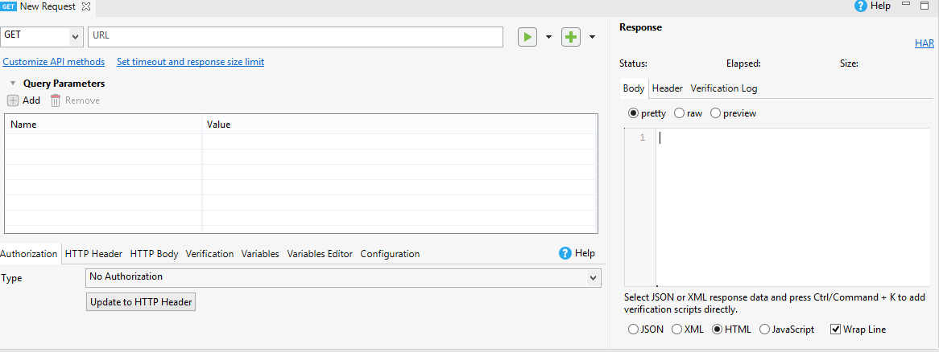

**1.Request method :**

Choosing one of the following method request method “GET,PUT,POST,DELET”.Method is need to url and then valid date request url

2.Request url :

Need the add the Request url

3. **Authorization:**

It is the part of api.user should access the url under permission(unless the date is public)

**4.Verification :**

Katalon has lot of verification method .click on verification tab it show the type

For example:

Verify json body data click on “**Response body : Json Value check**”

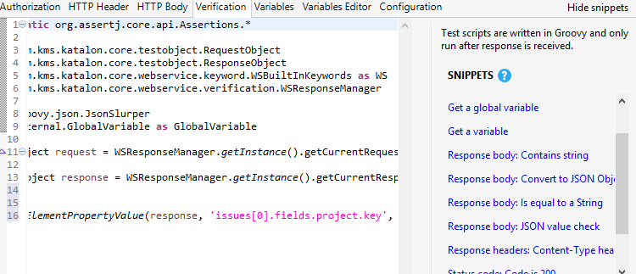

It will automatically give the groovy script.after you should replace “**issues[0].fields.project.key', 'KTP'”** give you json xpath and then KTP value should replace the response json input value

**Variable :**

Variables make API testing more and dynamic with the data-driven approach. Every part request can be parametrized .dynamic data can be used for url,header,Http Body. Following variable we can use Katalon Global,string,boolean,Testdate.have mention the screen short below how to declare the variable how can pass into the url or HTTP body

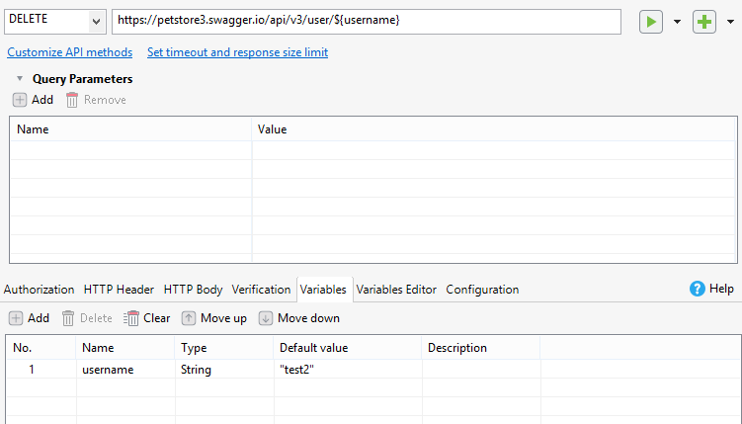

Replace sting value using that **syntax: ${uservariablename}** can use url,httpbody

**Calling object repository step into testcase**:

Add the request steps in object repository testcase level for managing the report.

Click on green arrow we have add the request step into our testcase level



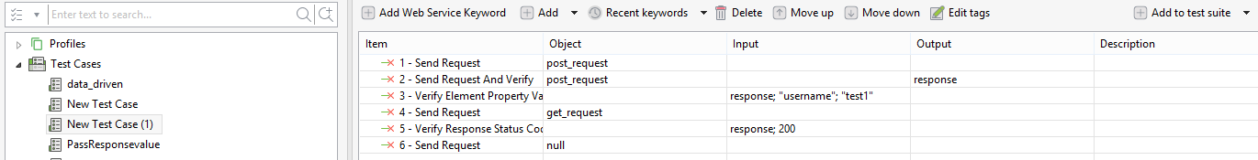

A testcase request can be inserted in to the “”ADD Web services keyword”.They are many keyword can be used send request, verify the response

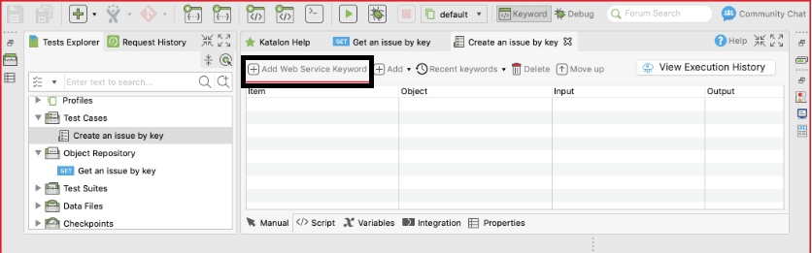

In team fields selected dropdown the option depends upon your testcase requirement. how we can call the request with verification steps from a test case:

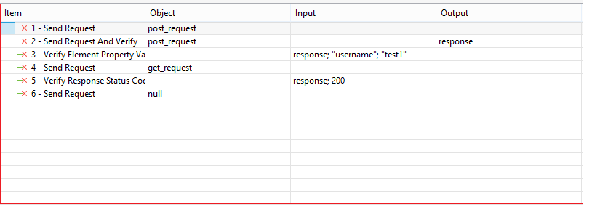

Click on object tab select your request step form the **object Repository** then added into it.

Add input field: click on input field tab

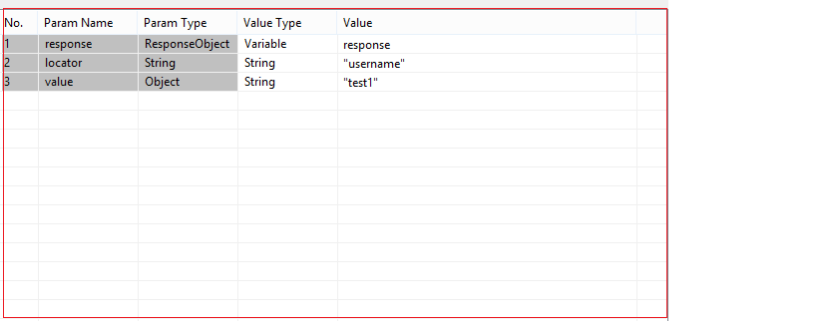

Define your value type and value. Then value should be automatically pass in to input tab.

### **Add the test case to the test suite:**

Collection of multiple testcase is called test suite.

Click on Test Suite tab have inserted testcase. have to show the screen short in below

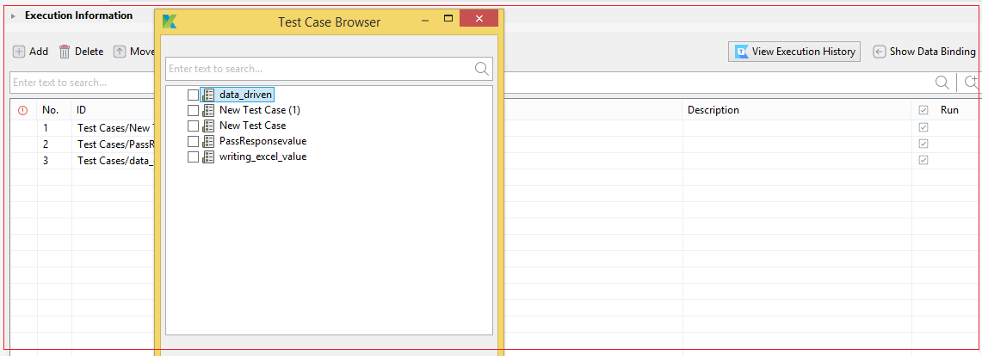

**Log Viewer:**

After Running the testcase or testsuit user should be test output in log viewer

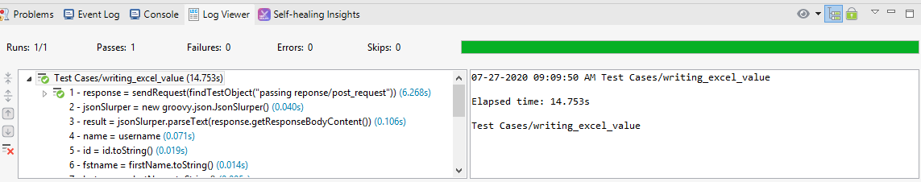

Read value Excel :

In katalon have inbuild tools read the data from the external file.

Click->Datafile->New->Test Data->enter name->select Datatype(excel,csv,Database)->ok

View the “File information” tab.select your file path and select the sheet name

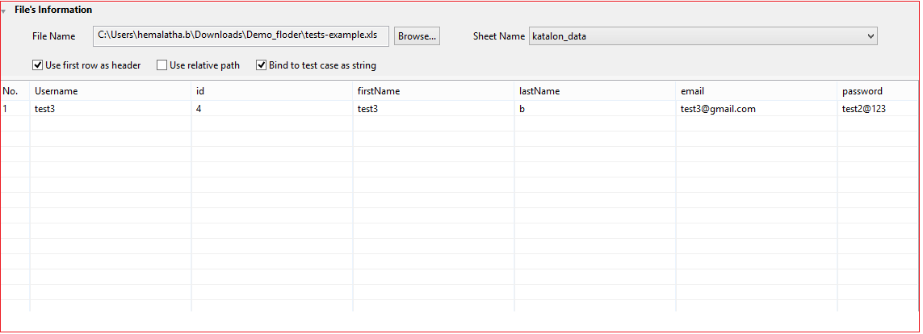

You excel data should view in the tab and testcase move into the testsuite.afterthate data should binding test suite.click on “**Show data Binding**”

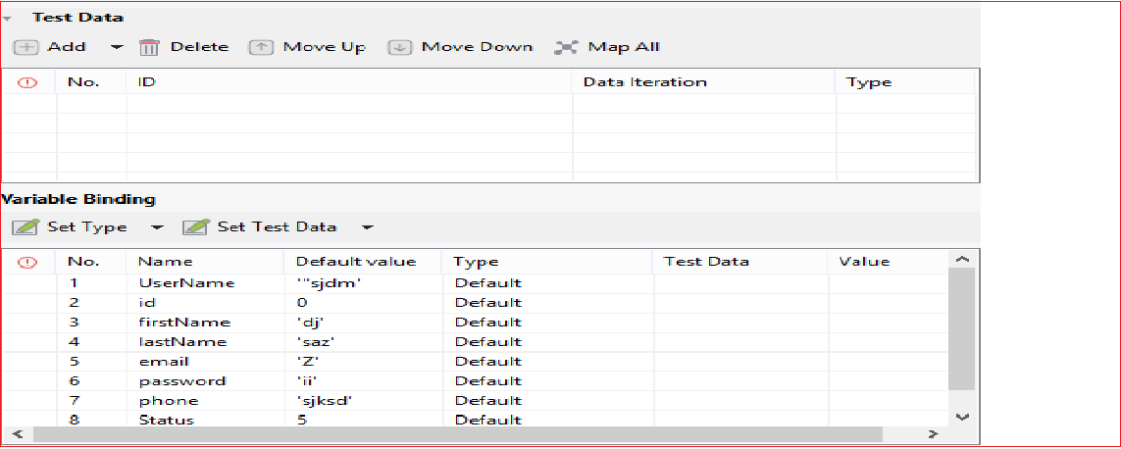

Click add button your internal file should be adding into the TestData.After that view the variable Binding tab.

1.Select **Type f**rom the dropdown (data column)

2.Select Test Data from and Value the dropdown

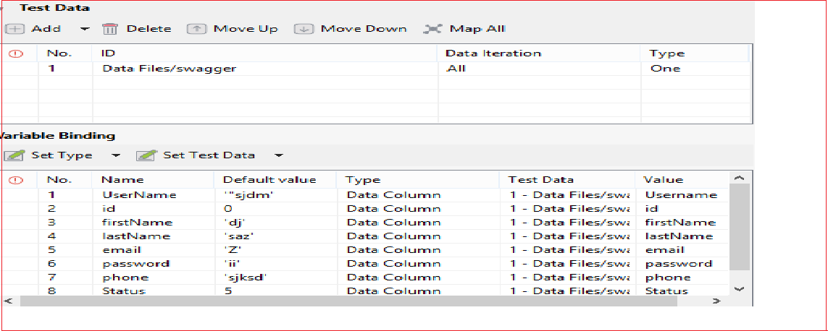The value should be pass into the testcase

Refer below link :

1.<https://docs.katalon.com/katalon-studio/docs/create_first_api_test_katalon_studio.html#step-4-create-a-new-test-case-with-an-existing-request>

2.<https://docs.katalon.com/katalon-studio/docs/ddt.html>